**Supplementary information**

**Structural Analysis of Triaxial Woven Fabrics and associated Composites**

Bo Songa,b, Guochang Lina,b*, Shaozhu Liuc, Ruiqiang Mad, Xueyan Chena,b Huifeng Tana,b*

*a Center for Composite Materials and Structures, Harbin Institute of Technology, Harbin, 150080*

*b National Key Laboratory of Science and Technology on Advanced Composites in Special Environments, Harbin Institute of Technology, Harbin 150080*

*c Pipe China North Pipeline Company Langfang 065000*

*d Institute of Applied Mechanics, Taiyuan University of Technology, Taiyuan 030024, China*

**Derivation of the structural model**

**S0—Table of Symbols**

To facilitate clarity, the symbols used in the manuscript and their corresponding physical meanings are summarized as follows:

|  |  |  |
| --- | --- | --- |
|  | *—* | *Side length parallel to the 0° fiber of the hexagonal pore* |
|  | *—* | *Other side lengths of the hexagonal pore* |
|  | *—* | *Bundle width* |
|  | *—* | *Braiding angle* |
|  | *—* | *Side length of the triangular pore* |
|  | *—* | *The spacing between the 0° fiber* |
|  | *—* | *The length of the unit cell* |
|  | *—* | *The width of the unit cell* |
|  | *—* | *A factor of triangular pores,* |
|  | *—* | *The area of the hexagonal pore* |
|  | *—* | *The area of the triangular pore* |
|  | *—* | *Porosity* |
|  | *—* | *Section width of the bundle at the angle of* |
|  | *—* | *The thickness of the yarn bundle* |
|  | *—* | *The spacing between adjacent bundles* |
|  | *—* | *Cross-section arcs central angle of the bundle* |
|  | *—* | *Cross-section arcs radius of the yarn bundle* |
|  | *—* | *buckling angle* |
|  | *—* | *Thickness of the Woven fabric* |
|  | *—* | *Carbon fiber volume fraction* |
|  | *—* | *The number of fibers contained in a single bundle* |
|  | *—* | *The cross-sectional area of a single fiber* |

**Noted：The prime symbol (') denotes physical quantities associated with TWFC**

**S1—In-Plane Structural Modeling of TWF**

Based on the physical TWF, an in-plane structural model is constructed as shown in Fig. A.1. Subsequently, a Representative Volume Element (RVE) of the TWF structure is selected. According to the weaving architecture of TWF, correlation equations for the in-plane structural parameters can be established.

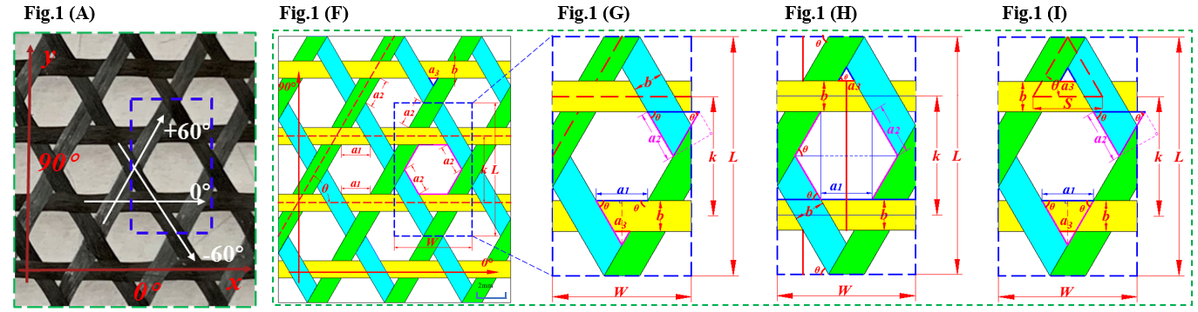

**Fig. A.1 In-plane structural model of TWF**

First, based on Fig. A.1 (G), Eqs.- can be derived using triangle similarity. 



To establish a more universal geometric description of the meso-structure of TWF,  was defined. Consequently,  and  can be expressed as Eqs.-:





According to Fig. A.1 (H), the total length *L* can be obtained by summing the lengths of the longitudinal red lines, while the total width *W* corresponds to the sum of the transverse blue lines.





From Fig. A.1 (I), the areas of the unit cell and the pore can be calculated respectively, yielding:







Meanwhile, the same results can be derived based on geometric relations:



Further, as shown in Fig. A.1 (I), the porosity can be calculated as:



By substituting Eqs.-into Eq. and simplifying, the expression for porosity can be obtained as:



Thus, the in-plane structural parameter equations of the TWF have been established, including the hexagonal pore size, triangular pore size, unit cell size, spacing between adjacent fiber bundles, and porosity—all of which are functions of the weaving angle, fiber bundle width, and λ. Their relationships can be concisely expressed by the following equation:





**S2—Cross-sectional Structural Modeling of TWF**

Based on the physical TWF sample, the cross-sectional structural model was constructed, as illustrated in Fig. A.2. The fiber bundle cross-sectional shape is assumed to remain constant along the fiber path. Furthermore, the cross-section of the fiber bundle is hypothesized to adopt an "eye-shaped" geometry bounded by two circular arcs. Based on these geometric assumptions, the relationships among the physical parameters of the TWF cross-sectional model can be derived.

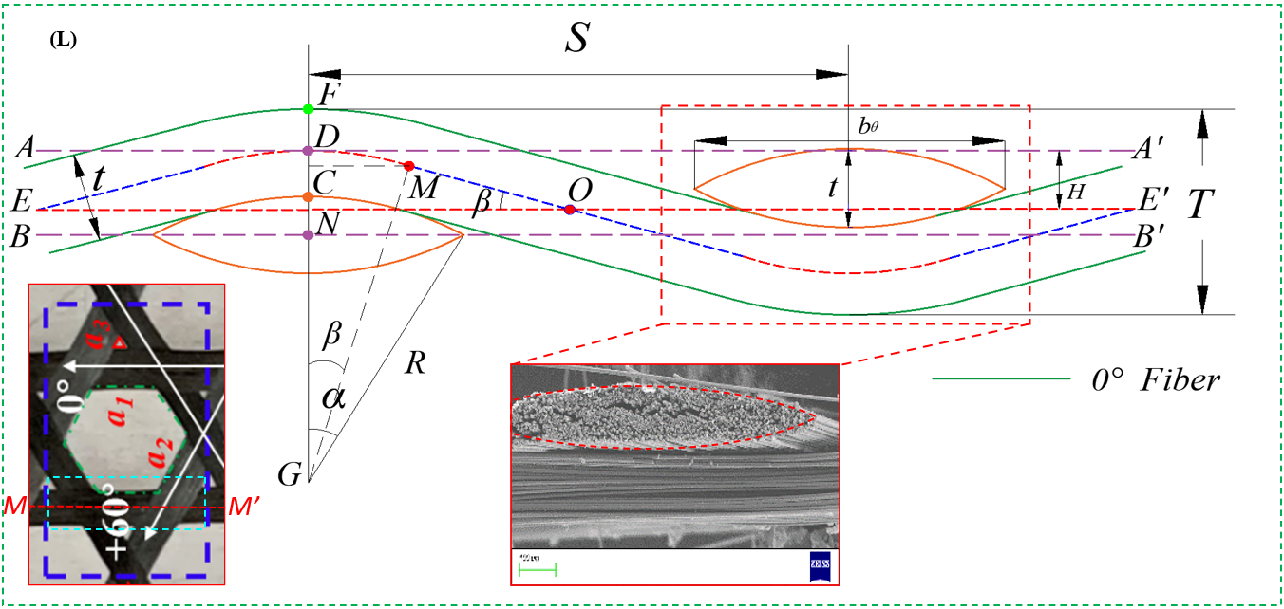

**Fig. A.2 Cross-sectional structural model of TWF**

By sectioning the unit cell along *M-M'* and analyzing the geometric parameter relationships within the cross-sectional structure, and based on the assumption that the fiber bundle cross-section adopts an eye-shaped profile bounded by two circular arcs, the following expressions can be derived:







Furthermore, the thickness of TWF can be expressed as:



By substituting *H* calculated from the geometric relationship into Eq., the expression for the thickness of TWF can be obtained:



According to Eqs. and, *R* and *α* can be expressed in terms of *b*, *t*, and *θ*.





Therefore, the thickness of TWF is a function of the braiding angle (*θ*), fiber tow width (*b*), fiber tow thickness (*t*), fiber tow buckling angle (*α*), and parameter *λ*.



The carbon fiber volume fraction of TWF can be characterized by the ratio of the total cross-sectional area of fiber filaments to the eye-shaped cross-sectional area.



Similarly, *R* and *α* can be expressed as functions of *b*, *t*, and *θ*. Consequently, the carbon fiber volume fraction depends on the braiding angle (*θ*), fiber tow width (*b*), and fiber tow thickness (*t*).



It can be readily observed that when , all the aforementioned equations degenerate directly to the idealized structural model of TWF.

**S3—Quantitative Correlation between TWF and TWFC Structures**

During the fabrication of TWFC, the textile structure undergoes vacuum compaction. Assuming uniform compression of fiber tows without twisting, the compaction process leads to an increase in tow width, a decrease in thickness, and a reduction in the buckling angle, thereby altering the TWFC architecture. As illustrated in Fig. A.3.

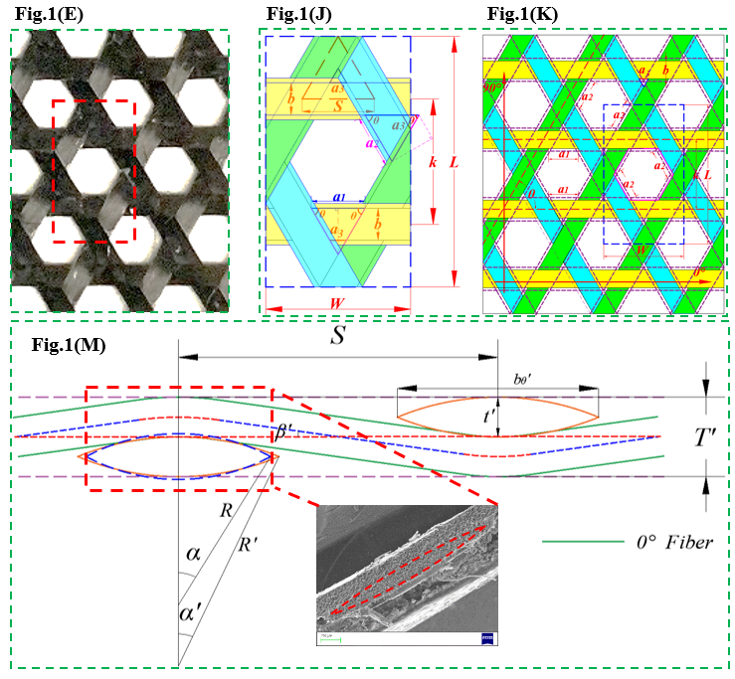

**Fig. A.3 Structural changes of TWFC after vacuum compaction**

Since the fabric is assumed to be uniformly compressed, the braiding angle of the fiber tows remains unchanged after vacuum compaction. Therefore, the equations in S1 remain applicable, though the variables within the equations change accordingly. Once specific design requirements are defined (e.g., complete closure of triangular voids), a direct correlation can be established between the TWF and TWFC geometric structures.

Variation in fiber tow width upon complete closure of triangular voids:



By substituting Eq. into Eqs.- and setting, the geometric parameters after vacuum compaction can be obtained.













Further, substituting Eq. into Eqs.- yields:





Where:





As evident from the equations, if the cross-sectional area of the fiber tow is assumed to change only in shape but remain constant in magnitude during vacuum compaction, a relationship between the compacted width and thickness can be established by equating the pre- and post-compaction cross-sectional areas (denominators in Eq. and Eq.). Consequently, by determining the buckling angle variation through an interpolation algorithm, the target design parameters of TWFC can be derived.